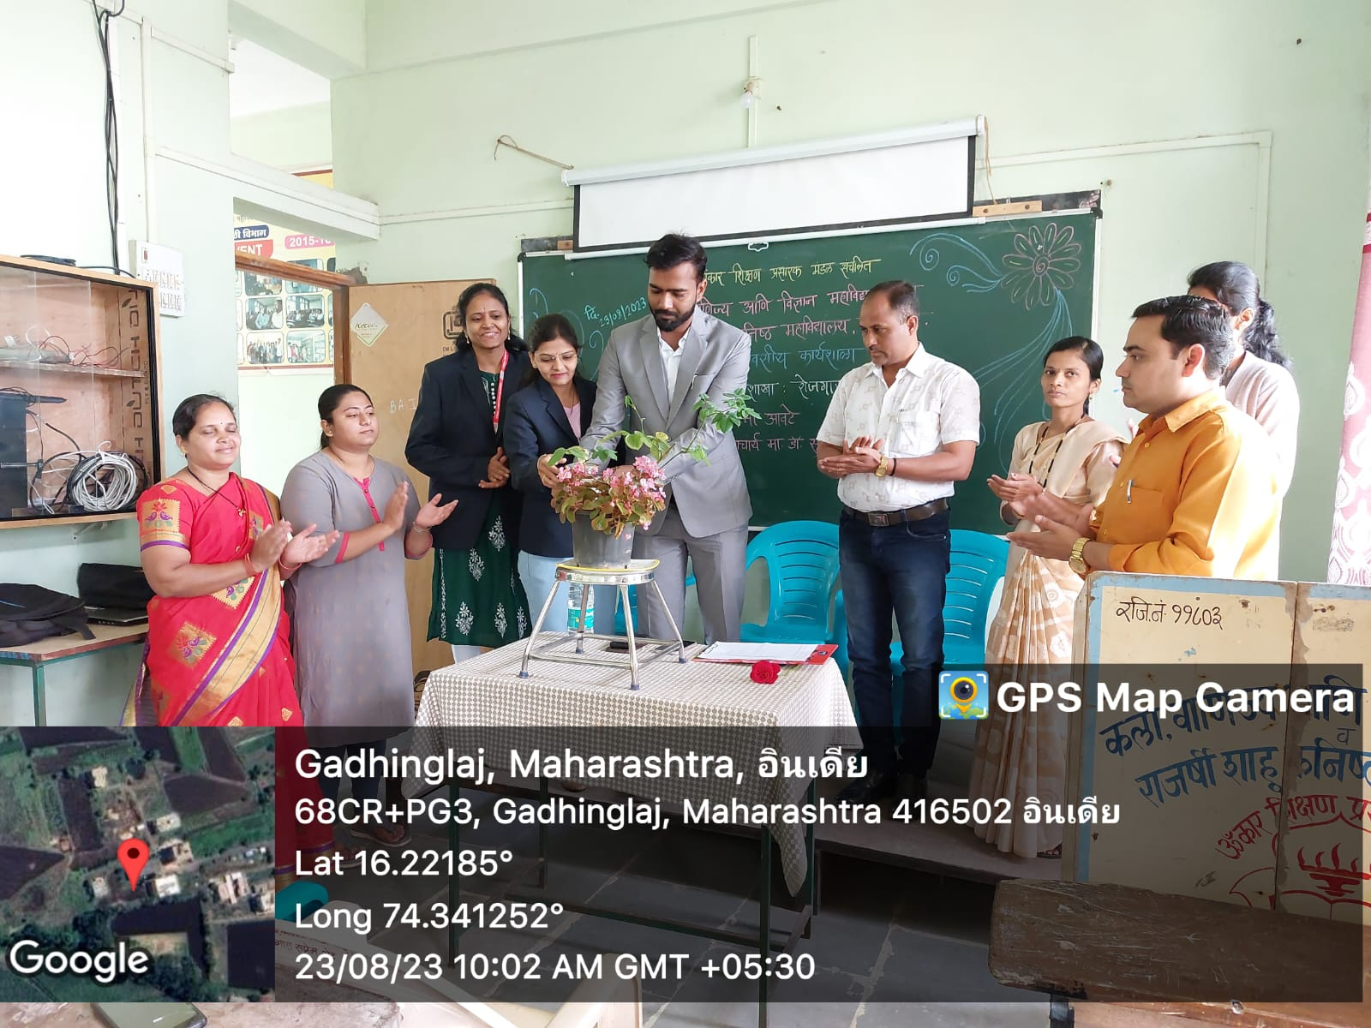
One Day Workshop on Commerce Branch: Job Opportunities

